About AmazonSmile
AmazonSmile is a website operated by Amazon with the same products, prices, and shopping features as Amazon.com. The difference is that when you shop on AmazonSmile, the AmazonSmile Foundation will donate 0.5% of the purchase price of eligible products to the charitable organization of your choice.
Every item available for purchase on www.amazon.com is also available on AmazonSmile (smile.amazon.com) at the same price. You will see eligible products marked "Eligible for AmazonSmile donation" on their product detail pages.
If you represent a charitable organization and you would like to learn more about registering your organization to receive AmazonSmile donations, go to org.amazon.com .
For more information about the AmazonSmile program, go to http://smile.amazon.com/about.

Go to smile.amazon.com and login to your regular Amazon.com account.

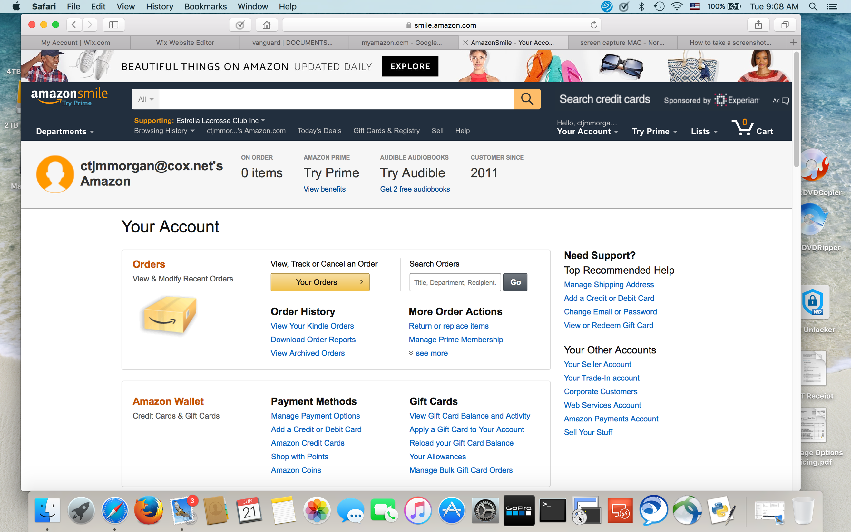

Click on “Supporting” to select or change charity designation

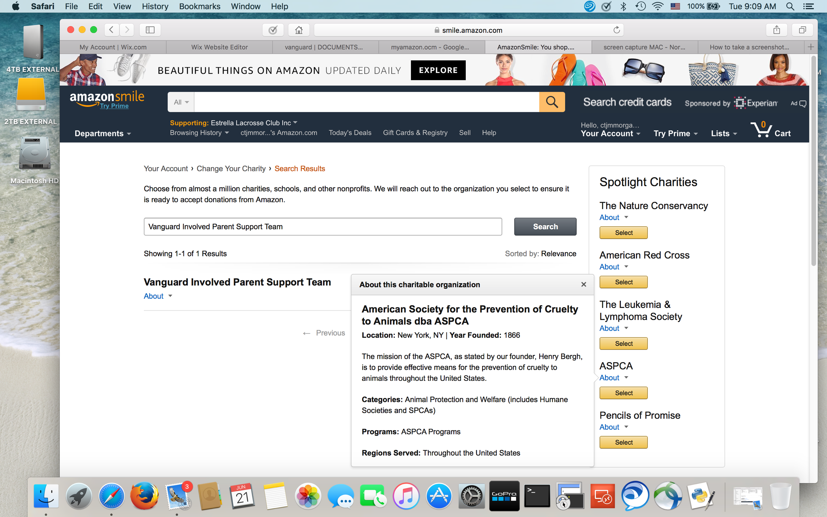

Click on “Change Your Charity”

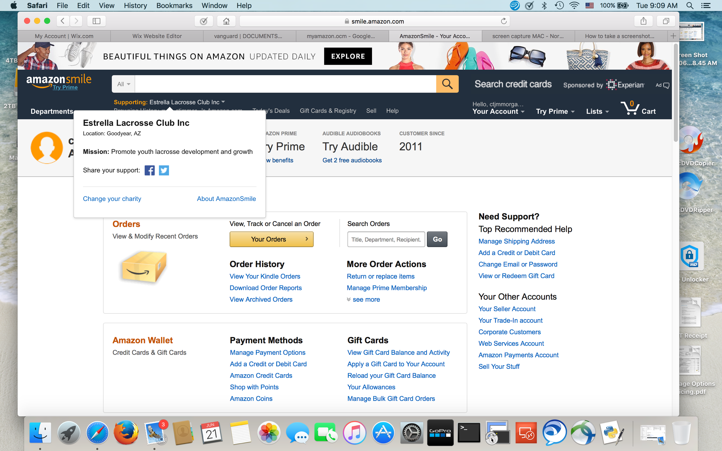

Search for “Vanguard Involved Parents Support Team” and “Select”.

